
Year 8

Term 1 Test

Resources allowed: Calculator and a handwritten A4 notes page double sided

Name: ______________________ Class: ______ Time: 50 minutes Total Marks: 52

- [4 marks]
Fill in the missing number in each of the following
a) b)

c) d)

- [5 marks]
Complete the following conversions:
- 3m = _____________mm
- 24cm = ___________m
- 34500m = ___________km
- 2cm² = ___________mm²
- 5000cm³ = ____________m³

- [1, 1 = 2 marks]
The perimeter of a rectangle is 36 m.
- Draw a rectangle with this perimeter and mark in a possible length and width.

- Find the area of your rectangle.

- [1, 1, 1, + 1 mark for all units = 4 marks]

Find the perimeter of the following shapes. Show your working clearly and giving your answers correct to two decimal places when necessary:
Shape | Working and Answer
a)
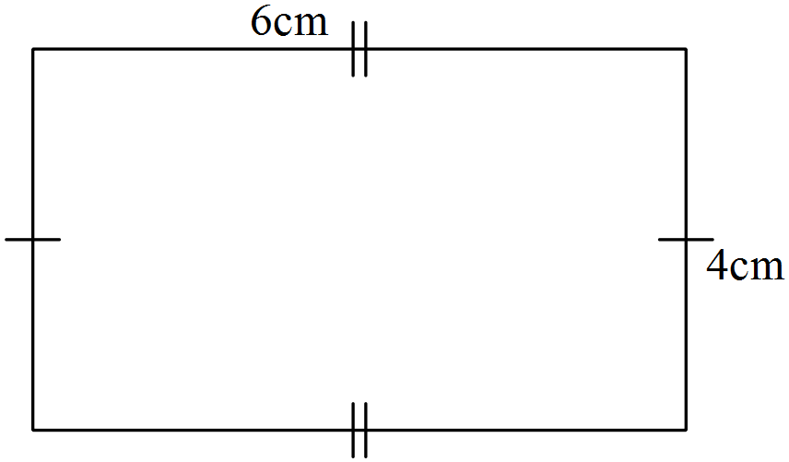

b)
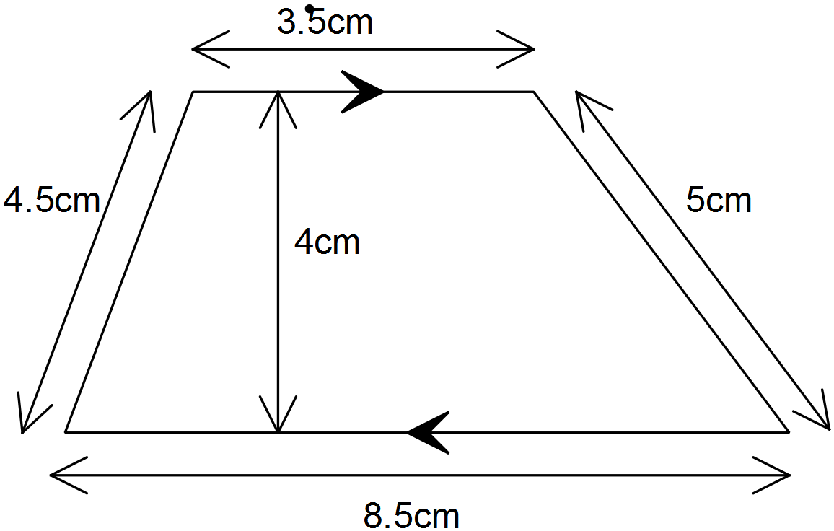

c)
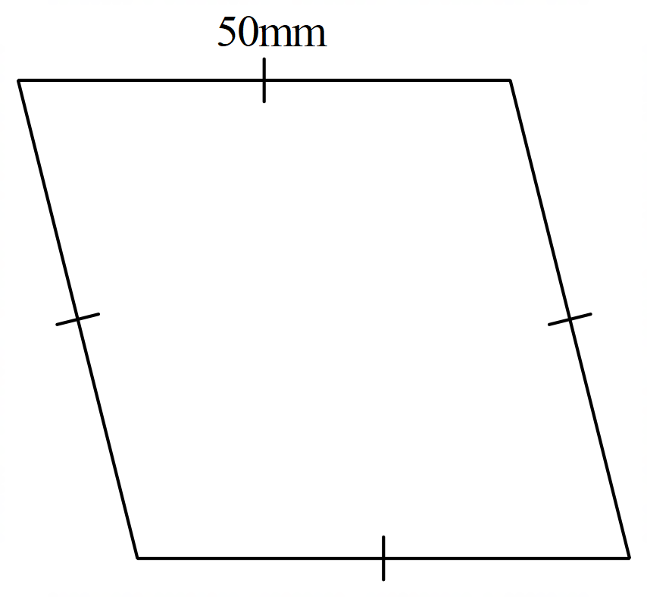

- [1, 2, 1 = 4 marks]
Find the area of the following shapes. Show your working clearly and give your answers correct to two decimal places when necessary.
Shape | Working and Answer
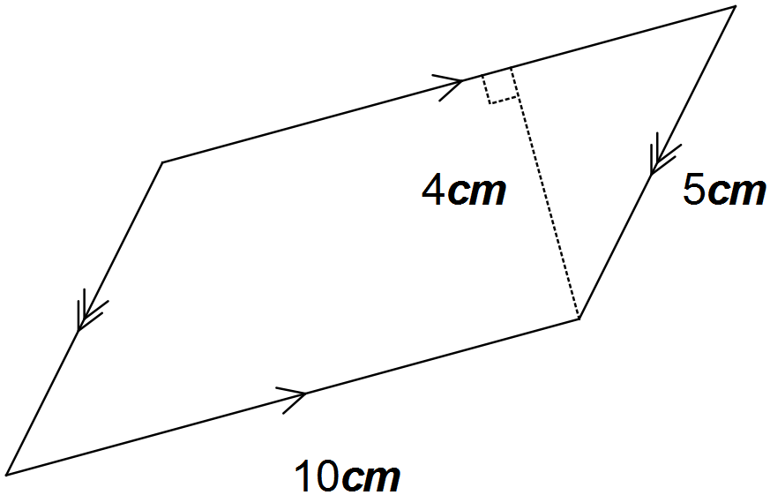a)

b)
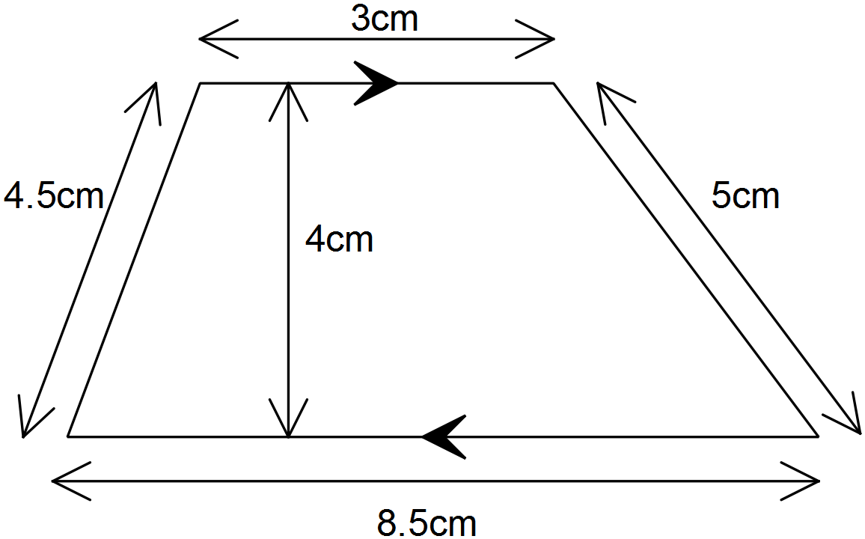

c)
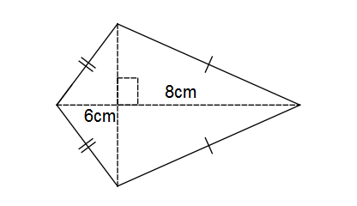

- [2, 2 = 4 Marks]
Calculate the volume of this prism:
Shape | Working and Answer
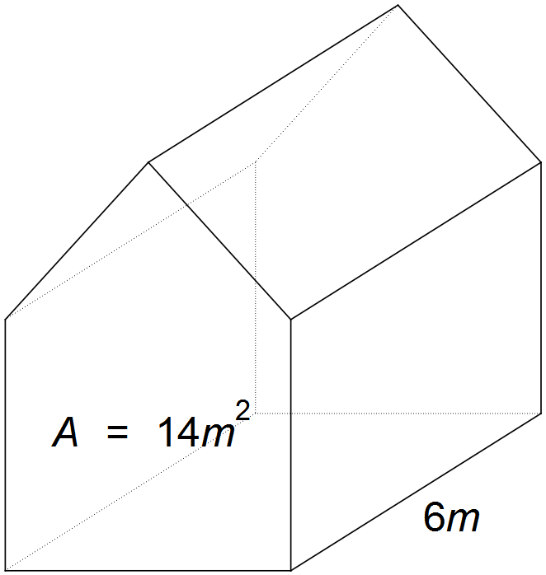

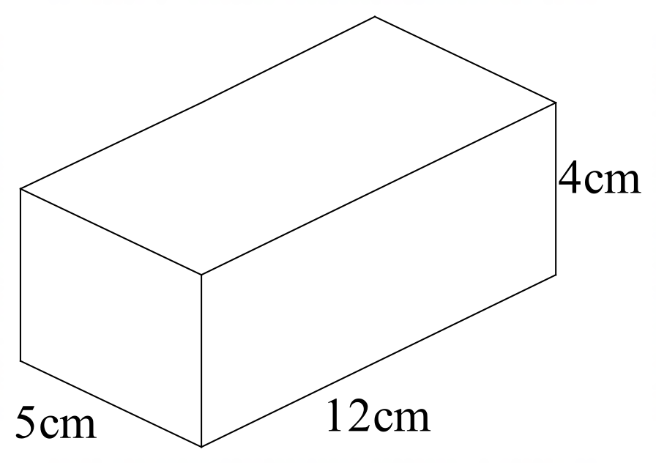

- [1, 1, 1 = 3 marks]
Express the following in simplest index form using the index laws

- (4³) ³ b) $\frac{6^{5}}{6^{2}}$

- 2³ × 2⁴

- [1, 1, 1, 1 = 4 marks]
Evaluate the following expressions, writing your answers as basic numerals (numbers):

- $2^{0}$
- $2^{5}$

- [1, 2, 2 = 5 marks]
Here are the results of a survey of cars passing the school.
Colour | Red | Blue | Yellow | Black | White
Number of cars | 7 | 19 | 4 | 23 | 27

- What is the experimental probability of a red car passing the school?

- Describe the complement of the event in part (a) and find its experimental probability of occurring.

- If a student was to repeat this survey again at the same time next week, recording colours until 100 cars had passed, how many of them would she expect to be yellow?

- [1, 1, 1 = 3 marks]
Write the complementary event for the following:

- It will rain today

- Rolling a 6-sided die and getting a 5

- You catch the bus home

- [1, 1 = 2 marks]
There are 10 counters in a bag. The counters are numbered 1, 2, 3, 4, 5, 6, 7, 8, 9, 10.
If one counter is drawn out at random, what is the probability that it is a counter:

- with an odd number

- that is greater than 6
- [2 mark]
The probability of selecting a blue marble from a bag of marbles is 0.3.

- Find P (Not blue)

- How many marbles could there be in the bag

- [1, 1 = 2 marks]
If we write the letters from the word MATHEMATICS on separate pieces of paper and place them in a bag, the probability of selecting an M is: P(M) = $\frac{2}{11}$.
a) Write down a word which has P(D) = $\frac{1}{4}$.

b) Write down a word which has P(vowel) > P(consonant).

- [ 8 marks]
For each of the following questions list the sample space and find the probability of the event occurring
Event | Sample Space | Probability of event occurring
- Tossing a coin and getting a head

- Rolling a normal die and getting a 4
- Choosing a red marble from a bag containing one red, one blue and 3 green marbles

- Rolling a normal die and getting an odd number

